Purpose: | To provide a process approach model for standardized workflows, identify decision points, and improve the Company’s OHSMS.
Scope: | Applicable to all project operations, work activities, and services provided by the Company including installation, testing, commissioning, and maintenance work at project sites.
ISO Reference: | MS ISO 9001:2015 & MS ISO 45001:2018 Clause No. 4.4

Revision History
Revision No. | Revision Date | Originator | Description of Changes

Definitions
OH&S | Occupational Health And Safety
OHSMS | Occupational Health And Safety Management System

Annex E – Operations Process Chart
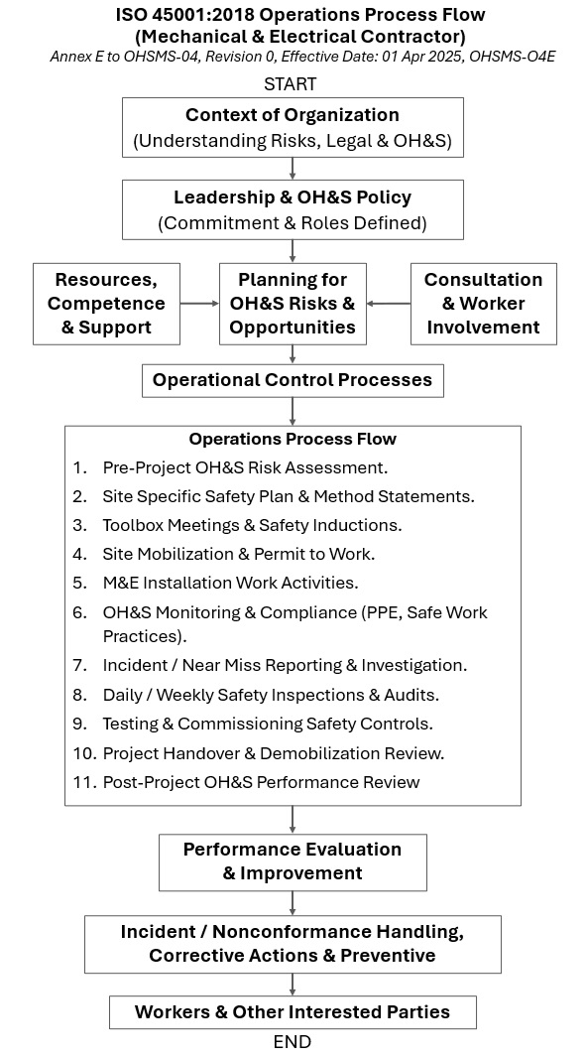

Prepared By:  Name: Philip Yong  Appointment: ISO Manager (IM)  Date: 01 Apr 2025 | Approved By:  Name: Ong Lay Cheong  Appointment: Managing Director (MD)  Date: 01 Apr 2025

End

